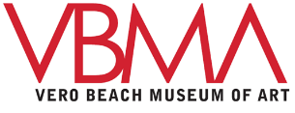

Veterans Program Registration Form
The Power of Photography
Tuesdays, January 7-February 4, 2020
6:00-8:30pm

Participant Name:_____________________________________________________________
Email:____________________________________ Home phone:_______________________
Cell phone ________________________________
Address:_____________________________________________________________________
City/State:___________________________________________ Zip code:_________________
Are you a Museum Member? ____Yes _____No
Emergency Contact Name/relationship/phone:_____________________________________________________
___________________________________________________________________________
The Vero Beach Museum of Art takes photos of program participants for archival and promotional purposes. Does the Museum have permission to take pictures of you? These images may be used in marketing materials. YES ____ NO____
On occasion, photographers from local newspapers and magazines may take photos for media use during programs. Will you permit these media images to be taken? YES___ NO___

Please return your registration form to Vero Beach Museum of Art 3001 Riverside Park Drive Vero Beach, FL 32963, attention Dawn Miller, Community Mural Project, or email to dmiller@verobeachmuseum.org. Contact Dawn Miller, Art for Health’s Sake Program Manager, with questions: (772)231-0707 ext.155

